FACULTY EVALUATION
Programme Name: SEP Scale Masterclass Module 2 Tanzania (25th May 2026 - 29th May 2026)
Session: Long-term sustainability planning
Faculty Name: Dr. Geoffrey Ikavulu Injeni
No. of Respondents: 13
No. of Participants: 13
Evaluation Parameter | (%) Individual Score | (%) Programme Average
Punctuality (Commencement and Completion of Sessions) | 97 | 95
How well do you understand the core concepts presented? | 86 | 90
Rate your confidence in applying the new skills learnt | 90 | 87
Degree of Faculty preparedness for the sessions | 97 | 92
Content and methodology of the program | 93 | 90
Quality of class and group discussions | 91 | 90
The information presented in the course is relevant to my work (ministry) | 94 | 90
Average scores | 93 | 91

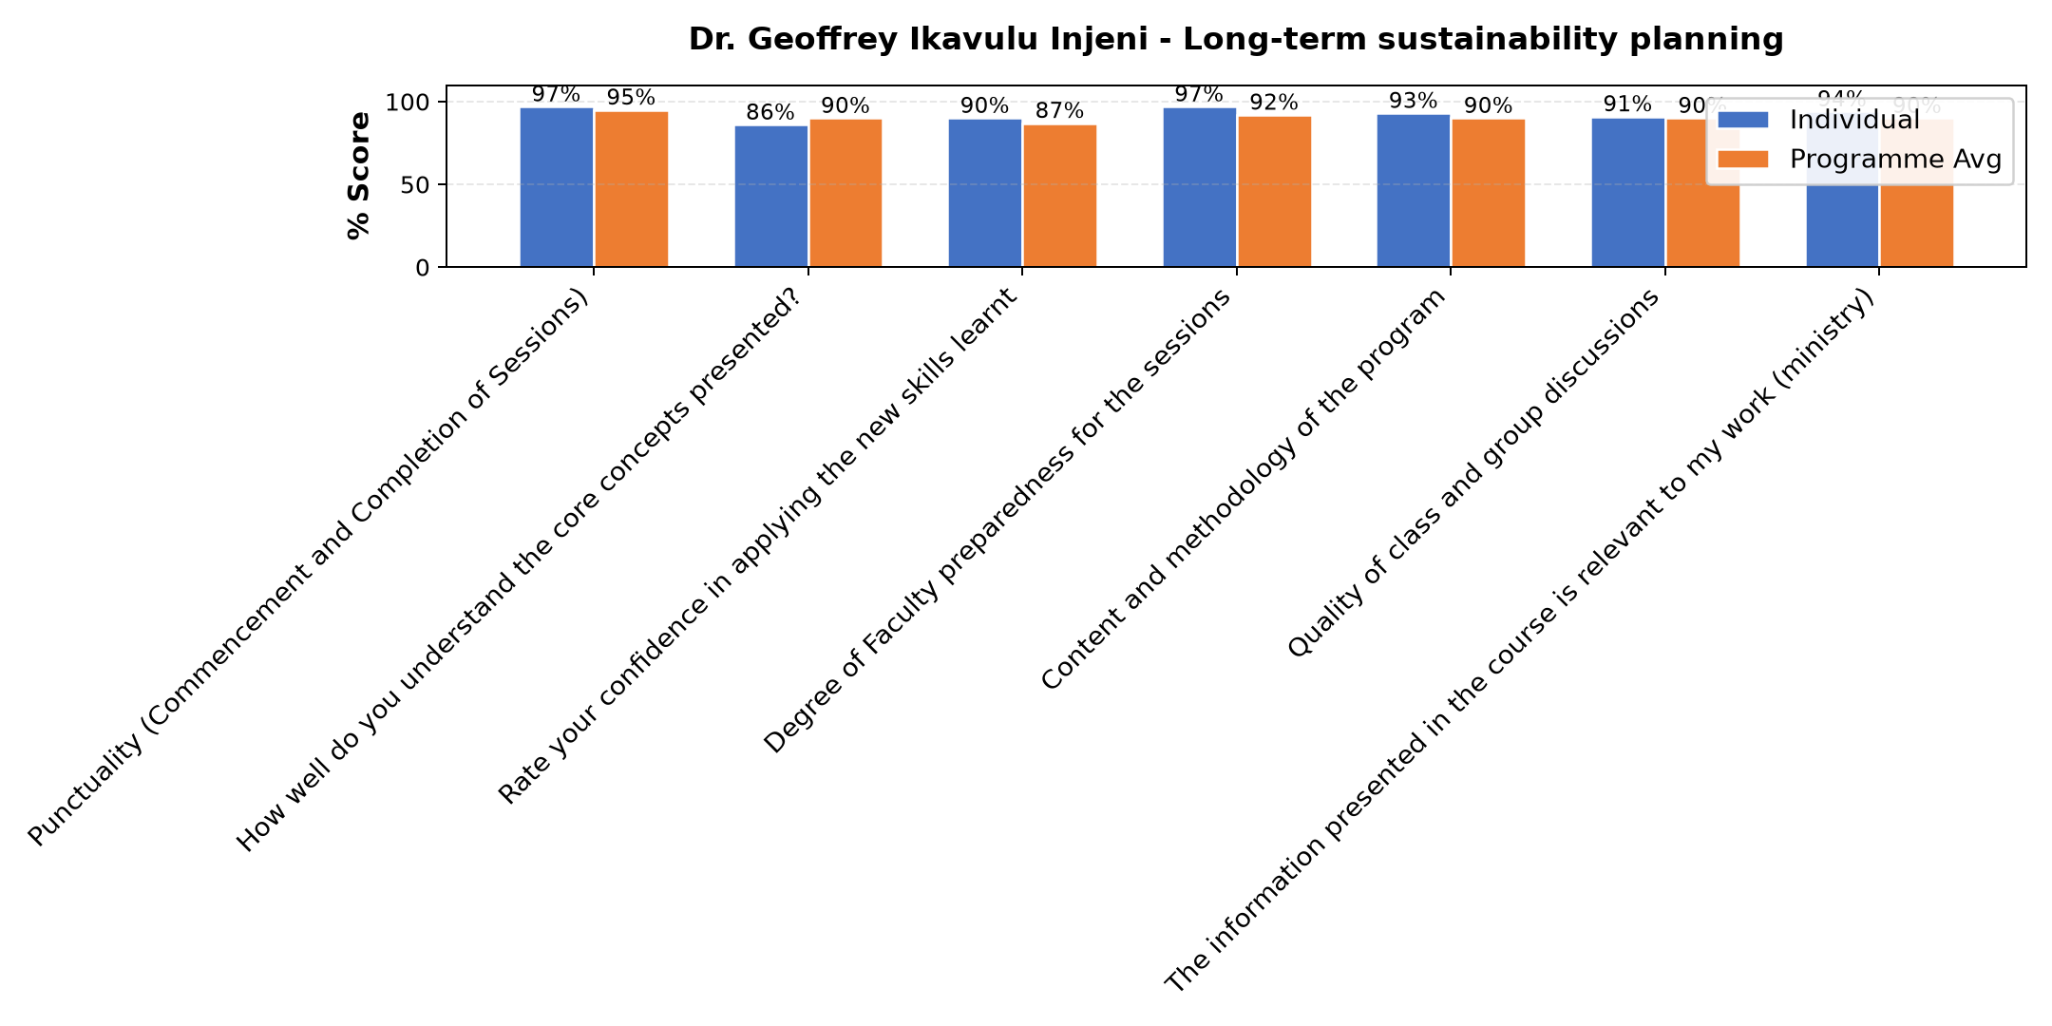

Comments & Feedback
- • Some barriers that might prevent me from applying what I learned about long-term sustainability planning include, lack of enough time for proper implementation and follow-up, insufficient support from stakeholders, and challenges in maintaining consistency in planning and monitoring activities. Changes in market conditions and limited access to reliable data may also affect effective long-term planning.
- • The possible barrier would be managing long-term assets which we buy and remain unused for long time. For instance, we bought land 3 years ago for construction but we are still unable to construct due to financial difficulties.
- • No barriers encountered so far. May be during implementation it might occur.
- • There is no berries is just considering what has been said.
- • May be lack of finance or climate change
- • Capotal
- • I will try hard to,aply the methods you taught us
- • No
- • No any barriers
- • Internet
SUBMITTED THROUGH:
SBS Evaluation Automation System

